## Supplementary 4: Survival Analysis (Forest Plots)

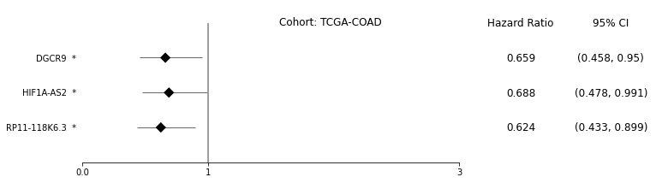

**Figure 1**: Forest plot of survival analysis with significant lncRNAs on TCGA-COAD cohort. The asterisks represent the Log-rank P-values: (* - P ≤ 0.05, ** - P ≤ 0.01, *** - P ≤ 0.001, **** - P ≤ 0.0001)

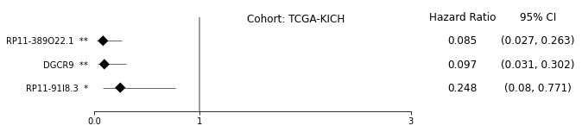

**Figure 2**: Forest plot of survival analysis with significant lncRNAs on TCGA-KICH cohort. The asterisks represent the Log-rank P-values: (* - P ≤ 0.05, ** - P ≤ 0.01, *** - P ≤ 0.001, **** - P ≤ 0.0001)

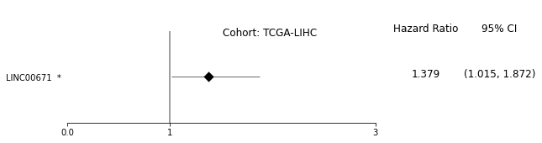

**Figure 3**: Forest plot of survival analysis with significant lncRNAs on TCGA-LIHC cohort. The asterisks represent the Log-rank P-values: (* - P ≤ 0.05, ** - P ≤ 0.01, *** - P ≤ 0.001, **** - P ≤ 0.0001)

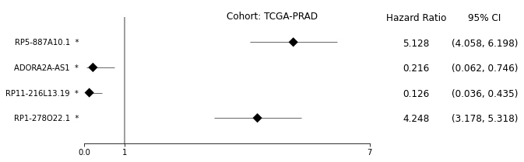

**Figure 4**: Forest plot of survival analysis with significant lncRNAs on TCGA-PRAD cohort. The asterisks represent the Log-rank P-values: (* - P ≤ 0.05, ** - P ≤ 0.01, *** - P ≤ 0.001, **** - P ≤ 0.0001)

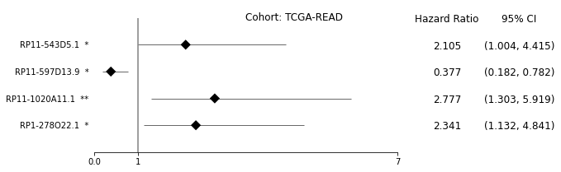

**Figure 5**: Forest plot of survival analysis with significant lncRNAs on TCGA-READ cohort. The asterisks represent the Log-rank P-values: (* - P ≤ 0.05, ** - P ≤ 0.01, *** - P ≤ 0.001, **** - P ≤ 0.0001)

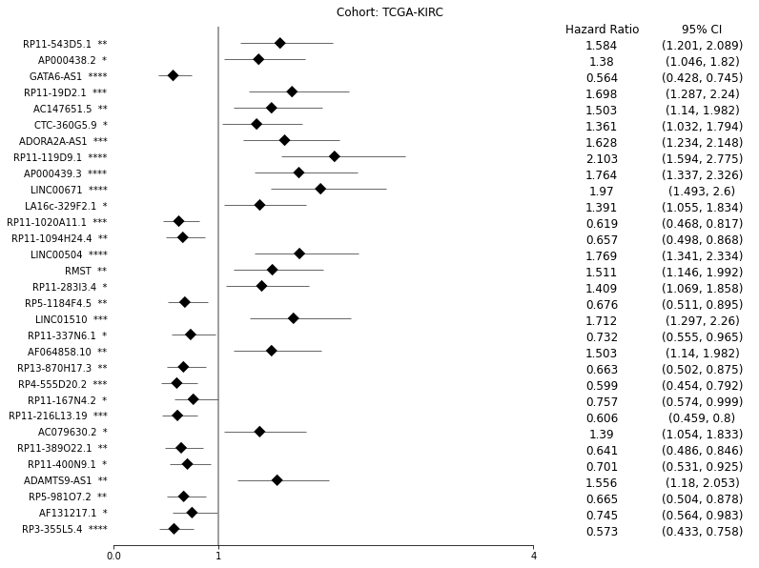

**Figure 6**: Forest plot of survival analysis with significant lncRNAs on TCGA-KIRC cohort. The asterisks represent the Log-rank P-values: (* - P ≤ 0.05, ** - P ≤ 0.01, *** - P ≤ 0.001, **** - P ≤ 0.0001)

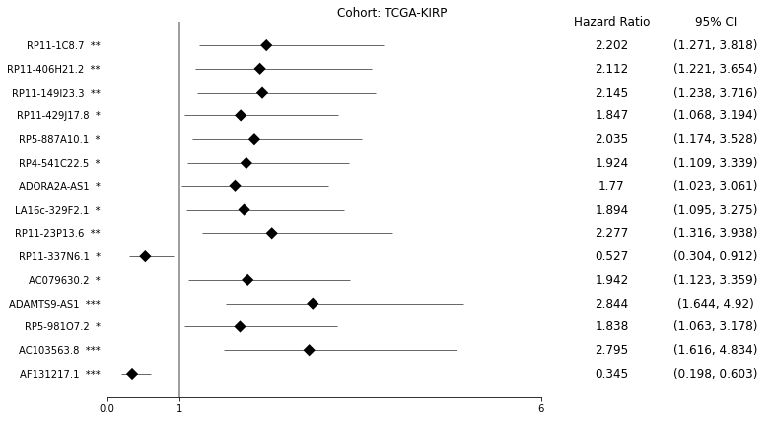

**Figure 7**: Forest plot of survival analysis with significant lncRNAs on TCGA-KIRP cohort. The asterisks represent the Log-rank P-values: (* - P ≤ 0.05, ** - P ≤ 0.01, *** - P ≤ 0.001, **** - P ≤ 0.0001)

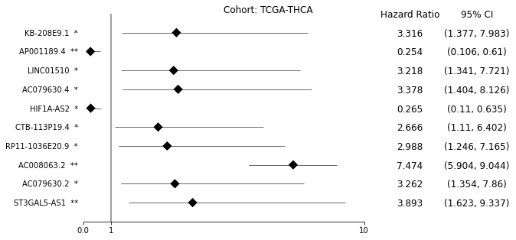

**Figure 8**: Forest plot of survival analysis with significant lncRNAs on TCGA-THCA cohort. The asterisks represent the Log-rank P-values: (* - P ≤ 0.05, ** - P ≤ 0.01, *** - P ≤ 0.001, **** - P ≤ 0.0001)

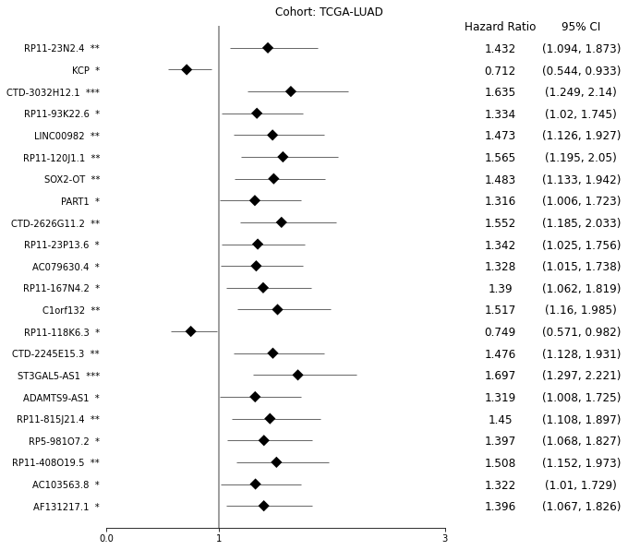

**Figure 9**: Forest plot of survival analysis with significant lncRNAs on TCGA-LUAD cohort. The asterisks represent the Log-rank P-values: (* - P ≤ 0.05, ** - P ≤ 0.01, *** - P ≤ 0.001, **** - P ≤ 0.0001)

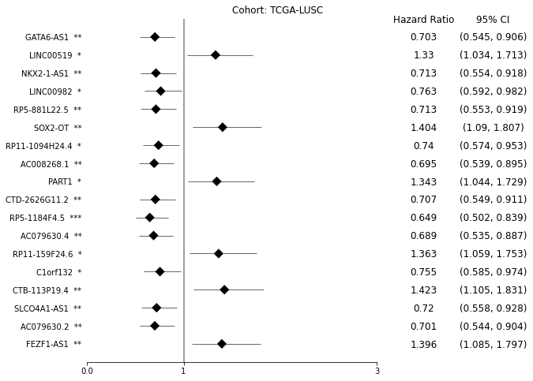

**Figure 10**: Forest plot of survival analysis with significant lncRNAs on TCGA-LUSC cohort. The asterisks represent the Log-rank P-values: (* - P ≤ 0.05, ** - P ≤ 0.01, *** - P ≤ 0.001, **** - P ≤ 0.0001)